NALEMA INTEGRATED COMMUNITY BASED
COASTAL FISHERIES MANAGEMENT PLAN
2023 – 2033

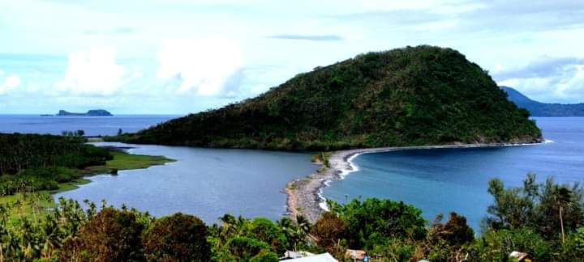
Photo: By Willie White for Tokoriki Local String Band

Fisheries Sector Case Study

Climate Information Services for Resilient Development Planning in Vanuatu
Vanuatu Klaemet Infomesen blong redy, adapt mo protekt (Van-KIRAP) Project

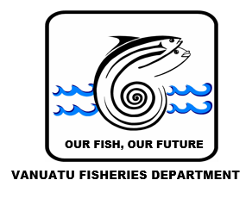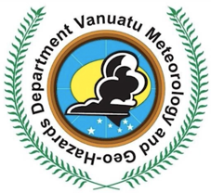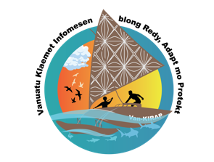

Nalema Community Based Fisheries Management plan 2023 – 2033.

Fisheries Sector Case Study: Climate Information Services for Resilient Development in Vanuatu or Vanuatu Klaemet Infomesen blong redy, adapt mo protekt (Van-KIRAP) Project

Vanuatu Meteorology and Geohazard Department
Ministry of Climate Change
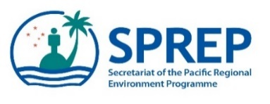

Approval of Nalema Community Based Fisheries Management Plan
By virtue power conferred upon the people and communities of Naleman, under section 5 of this plan, we the people of Nalema represented by our chiefs and supported by the Paramount Chief Supo of Filakara and Chairman of Yarsu Area Council hereby approve of this Community Based Fisheries Management Plan.

__________________________ _____________________________
Chief, Nalema Community PARAMOUNT Chief, FILAKARA CommuniTY

___________________________ ____________________________________________
CHAIRMAN, YARSU AREA COUNCIL Director, Vanuatu Fisheries Department

________________________________
President NALEMA Fishers association

Document is signed on this day ______of ___________ 2024

Acknowledgement

The Nalema Community Based Fisheries Management Plan is the result of contributions from the community of Nalema both in the village and in Port Vila. We thank the Chief and the community of Nalema for their contributions to the plan and the Vanuatu Fisheries Department as the leading Government Agency coordinating the develop of this plan, Vanuatu Meteorology and Geohazard Department and the Secretariat of the Pacific Regional Environment Programme (SPREP) for the management and coordination of the project, and the Green Climate Fund (GCF) for funding under the Climate Information Services for Resilient Development Planning in Vanuatu or Vanuatu Klaemet Infomesen blong redy, adapt mo protek (Van-KIRAP) Project through the Ministry of Climate Change to facilitate and secure budget to support Community Based Fisheries Management in Vanuatu.

Table of Content
Approval of Nalema Community Based Fisheries Management Plan 3
Acknowledgement 4
Table of Content 5
List of tables 6
Abbreviations 6
1. Introduction 7
2. Vision and objectives 8
2.1 Vision 8
2.2 Objectives 8
2.3 Development of this plan 9
2.4 Area affected by this plan 9
3. Financing the plan 10
4. Nalema environment, people and culture 12
4.1 Forest and agriculture resources 13
4.2 Aquatic resources and coastal environment 14
4.3 Marine resources 14
4.4 Fishing activities 14
4.5 Traditional management practices 16
4.6 Overfished resources 17
5. Problems and threats 18
6. Economic Activity in the coastal zone 20
6.1 Fishing activities 20
6.2 Copra production 20
6.3 Cattle sale (beef) 20
6.4 Root crops and vegetables 21
6.5 Tourism opportunity 21
6.6 Cooperative and Trade 21
6.7 Handicraft making 21
6.8 Transport services 21
7. Community based Fisheries management proposal 22
7.1 overexploitation of reef and lagoon resources 22
7.2 Monitoring of rock fishery resources and ciguatera fish poisoning 23
7.3 Lake Nalema and Kambioko Conservation Area development 24
7.4 Coastal wildlife conservation 25
7.5 Improve Fishing technology transfer and training 25
7.6 Fish marketing improvement and value adding of fish products 26
7.7 Fish catch data collection by electronic recording 27
7.8 Ecotourism development and handicraft making 27
7.9 Development of an Information centre 28
8.0 Management Institution 30
8.1 Area Council 30
8.2 Community development committees 30
8.2 Village Council 31
The village Chief and his Nasara Chiefs form the village Council whose role amongst others is to ensure 31
members of the community comply with the rules set out in this plan and the existing laws of the country 31
Governing marine and associated wildlife. The village council will enforce the following rules: 31
8.3 SDA Church 32
9.0 Implementation Strategy 32
9.1 Implementation strategy 32
9.2. Steps in implementation of the plan 34
10. Duration and Review 36
Annex 1. Vanuatu Fisheries Regulation for Marine Resources 37
Annex 2. Reef Fish Size Limit rule for Nalema (Proposed new rule) 38
Annex 3. Restricted Fishing gear and closed area 39

List of tables

Abbreviations
ADRA | Adventist Development and Relief Agency
CTI NAP | Coral Triangle Initiative National Action Plan
CBFM | Community based fisheries management
CDC | Community disaster committee
CCA | Community conservation area
EACFM & CCA | Ecosystem approach to coastal fisheries management and climate change adaptation
CSIRO | Commonwealth Scientific and Industrial Research Organisation
DEPC | Department of Environment Protection and Conservation
DoF | Department of Forestry
EBM | Ecosystem based management
EMC Act | Environmental Management and Conservation Act (2003)
FAD | Fish aggregating device
GCF | Green climate fund
VFD | Department of Fisheries
FAO | Food and Agriculture Organisation
ICM | Integrated coastal management
IWRM | International Water Resources Management (SOPAC Project)
LMMA | Locally Marine Managed Area
MALFFB | Ministry of Agriculture, Livestock, Forestry. Fisheries and Biosecurity
MPA | Marine Protected Area
NACCC | National Advisory Committee on Climate Change
NAPA | National Adaptation Programme of Action
NCBFMP | Nalema Community Based Fisheries Management Plan
CBFM | Community Based Fisheries Management
NGO | Non-Government Organization
NICMF | National Integrated Coastal Management Framework
SPC | Secretariat of the Pacific Communities
SPREP | Secretariat of the Pacific Regional Environment Programme
SPCZ | South Pacific Cnvergence Zone
SST | Sea surface temperature
VanKIRAP | Vanuatu Klaemet Infomesen blong redy, adapt mo protekt project
VBRMA | Village Based Resource Management Area
VMGD | Vanuatu Meteorology and Geohazards Department
VCAP | Vanuatu climate Adaptation Project

Introduction

Vanuatu is the world’s most at-risk country for natural disasters according to UN University of World Risk Index (UNU-EHS 2015). It’s location in the ‘warm pool’ of the South Pacific Convergence Zone (SPCZ) means its population is highly exposed to tropical cyclone activity. The country is highly exposed to natural disasters that affect the country including tropical cyclone, earthquakes, tsunamis, droughts, floods, volcanic eruptions, landslides, and coastal inundation. A total of 5 category 5 tropical cyclones have passed through the Vanuatu group since the 1970s which is the highest in the region putting the country at the high disaster risk. The weak economy, inadequate infrastructure, water and sanitation issues and lack of effective adaptation mechanism to disasters and coupled with climate changes present high vulnerability and susceptibility to even more damages during disasters.

Coastal communities of the Pacific islands region rely heavily on fisheries resources for their protein security and livelihood. In Vanuatu 80% of the population live in rural areas and agriculture and fisheries are the source of sustenance. Many coastal people who depend on fish for protein face climate shocks and stresses. Climate change will exacerbate non-climate pressures on fisheries resources such as overfishing, pollution and loss of habitat. Increasing temperatures, sea level rise and ocean acidification will affect the structure and productivity of marine and coastal ecosystems when all land-based resources are lost by natural disasters, fisheries resources become an important layback resource in maintaining healthy nutrition post disasters.

During the 2015 tropical cyclone Pam and the El-Nino draught fisheries become the centre of disaster relief and recovery. For example, the harvesting of sea cucumber injected over 300 million into the local economy in affected communities. Examining the vulnerability of fishing communities can assist identify actions to ameliorate adverse impacts. The islands of Vanuatu are mountainous distributed in the six Provinces of Torba, Sanma, Penama, Malampa, Shefa and Tafea from North to South with narrow coastal plains which makes them vulnerable to flooding and landslide. Some Islands are geologically young such as the shepherds Island and surrounded by cliffs which experience continuous erosion and landslide.

The country’s population is 319,137 as of 2021 national census and concentrated along the coastal environment that plays a vital role in the subsistence and commercial life of the Ni-Vanuatu people. Increased human activity in this coastal environment is placing greater pressure on sensitive areas such as beaches, coral reefs, seagrass and mangroves. The low-lying coastal areas of Vanuatu are particularly vulnerable to climate change consequences. Some of these climate related risks include the following:
• By 2040, daily temperatures will increase from 1995 levels by 1.2°C;
• Sea level rise will continue and accelerate, so risks of coastal inundation will be high when combined with storm surges and high seas;
• Ocean acidification may degrade 80% of coral reefs within 20 years;
• Extreme temperatures will reach higher levels and become more frequent;
• Extreme weather events, including cyclones and storms, will increase in intensity but not necessarily in frequency; and
• Dry periods will last longer and extreme rainfall will be more frequent and intense, so Vanuatu will be susceptible to intensified erosion and flooding.

The country’s economy is based primarily on small-scale agriculture, which provides a living for about two thirds of the population (and is a particular source of income and livelihood for women). Fishing, offshore financial services, and tourism (with nearly 197,000 visitors in 2008), are other mainstays of the economy. Most of the population does not have access to a reliable supply of potable water, though 94.5% has access to ‘improved’ water sources, and deforestation exists as a major environmental challenge.

The main climate hazards for Vanuatu include tropical cyclones with high winds and wave energy, heavy rainfall resulting in flooding, extended periods without rain causing drought, rising sea levels threatening coastal environments and property, as well as sea temperature increase and ocean acidification impacting highly valuable coastal ecosystems and resources (including coral reefs, seagrass and fisheries).

The Nalema Community Based Fisheries Management Plan (NCBFMP) provides roadmap for improved management of coastal resources, to ensure secure food supply and economic growth is balanced with sound environmental management. The plan is part of the fisheries sector component of the nationwide initiative to improve resilience and adaptation of island communities to the environmental changes brought about by climate change and global warming and ocean acidification. The activities required to achieve this goal are contributing to the national commitment to biodiversity and resource management within the area of Nalema and Epi Island in the Shefa province.

The Climate Information Services for Resilient Development Planning in Vanuatu or Vanuatu Klaemet Infomesen blong redy, adapt mo protect (Van-KIRAP) is a major project funded by the Green Climate Fund (GCF) to improve food security and livelihood of communities in Vanuatu by using climate information to prepare for and respond to marine heatwaves on coastal fisheries. The project location is Nalema, South Epi. The main activities to focus on in the coastal zone are:
- Community profile report for the two sites
- Community Based Fisheries Management plan development
- Setting up of coastal marine protected areas supporting
- FAD development and associated fisheries activities
- Coastal upland management to reduce run-offs
- Set-up Conservation Area at Lake Nalema and reforestation to recover the ecosystem.

For detail of project activities refer to the main project document.

Vision and objectives

2.1 Vision

The long-term vision of the Nalema CBFM Plan is to:
- To encourage sustainable use coastal resources to benefit the people now and in future generations.
- Climate adaptation of communities through coastal habitat restoration and protection of resources.
- Encourage management resource and better utilization from improved post-harvest and derive optimum economic return from the resources.
- Setting up Lake Nalema Conservation Area, reforestation of the swamp and terrestrial habitat to recover the ecosystem and biodiversity conservation.
- Develop capacity of community on improved skills and use of climate information to increase catch.

2.2 Objectives

The Nalema Community Base Fisheries Management plan promote ecologically sustainable utilization of marine resources and protection of Nalema coastal habitat, recovery of Lake Nalema ecosystem and the surrounding environment. The Plan provide roadmap for cooperation by community, fishers association, church, the Fisheries Department and other stakeholders who are involved in management and conservation of Nalema coastal marine resources. The Plan is developed in-line with the National Sustainable Development Plan or “the Peoples Plan” 2016-20130, Vanuatu National Integrated Coastal Management Framework, the National Fisheries Sector Policy 2016-2030, the National roadmap on coastal Fisheries and the Environmental Management Act, Its main objectives are to:
- Encourage and promote community based management in-line with national fisheries sector policy
- Sustainable harvest of marine and fisheries resources and minimize damage to the environment.
- Increase economic return from fisheries resources through improved decision-making process.
- Promote secure food supply and income generation now and in future.
- Promotion of scientific knowledge as the basis for sound decision making.
- Promote cooperation between all parties in the management of coastal zone of Nalema area.
- Encourage the setting up of conservation area to rehabilitate the Lake ecosystem which had suffered degradation from multiple sources.
- Identify priority actions for Van-KIRAP project implementation and provide action areas for other projects to come in and respond.

Development of this plan

The Nalema Community Based Fisheries Management Plan was created in consultation with the community. Baseline assessment surveys were conducted in 2020 and 2024 to gather information on resources, traditional governance and religion, development and economic activities, environmental conditions and disasters affecting the community. The consultation process was extended to Nalema community members in Port Vila who provided valuable information on issues facing the communities such as (i) resources, (ii) resources issues, (iii) traditional governance and religion, (iv) development and economic activities, (v) environment condition and disasters affecting the community. The goal was to maintain a functional coastal ecosystem in the face of climate change.

The community was given the opportunity to identify important issues and priority actions to address these issues in their respective communities. The identified issues were presented in a table which clearly states the issue, objective, proposed specific activities, responsible individuals, and outcome of the activities. The activities were left open without a date of achieving the target to allow for flexibility and opportunities for other projects to support and provide resources to implement the plan.

This plan is consistent with the Community Based Coastal Fisheries Management Planning process being promoted by the Vanuatu Fisheries Department throughout the country.

Area affected by this plan

The Nalema CBFM plan cover the area whole area of Nalema community coastal zones of the island which is defined as the area spanning from upland terrestrial forest inhabited by sea birds and crabs, rocky shores, coral reefs, lagoon and mangrove and offshore up to three miles provincial waters (Fig 2). The Community that will be affected by this plan are the people of Nalema. The plan is for Nalema Island community and and Yarsu Area Council however because fishing ground is shared with nearby Tongoa, the plan provide option for sharing of roles where communities of the three island communities seek to have some level of cooperative arrangement in future through the Shefa province. Within Nalema this plan is cantered around traditional marine tenure governance of the Nalema coastal area from the coast up to the upland boundary estimated by the yellow dotted line (Figure 2).

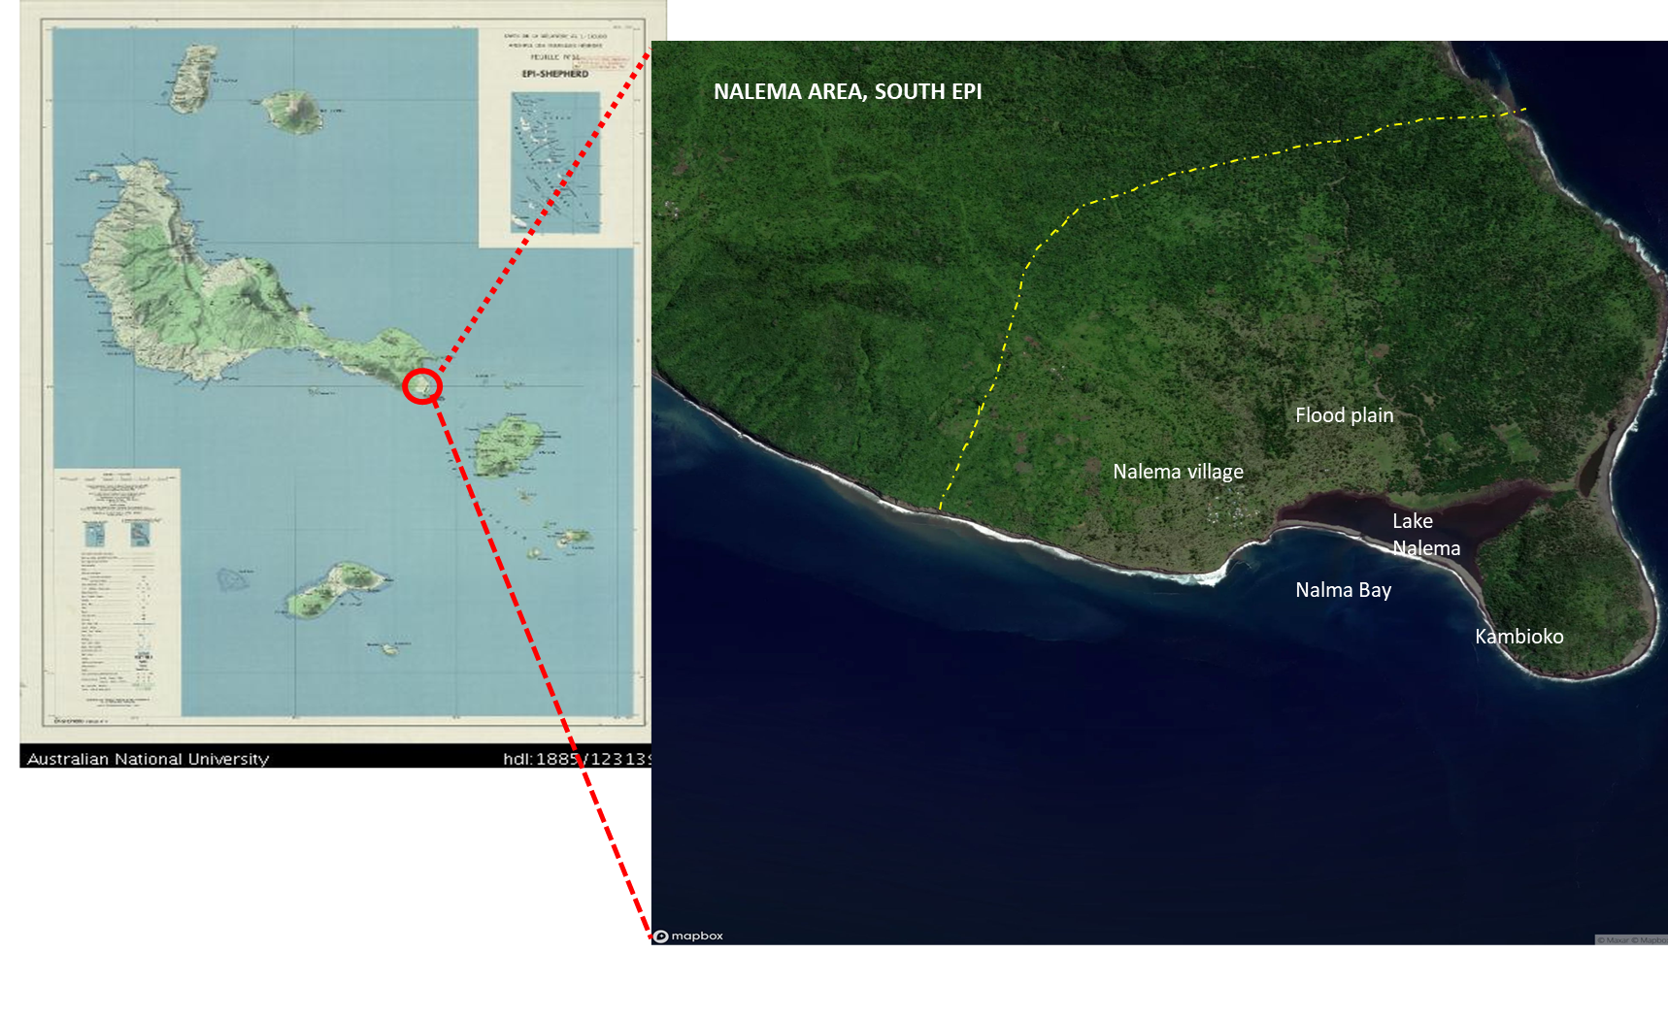
Figure 2: Map of Epi and Shepherds Island and Nalema Area (Google map, January 2024) – Yellow dotted line
is estimated boundary of Nalema Land.

Financing the plan

Implementation costs for the plan are built into the budgets of the Department of Fisheries for the years from 2020-2024 under the Van-KIRAP project funding, the VCAP II project and the Vanuatu Fisheries Department budget. The financing plan is divided into three components: (I). Baseline assessment of resource use, (II). Management and development planning and (III). Collection of climate information and building alliances and integration of activities. The disturbances of COVID and natural disasters experienced during the Van-KIRAP project period has and will affect implementation process resulting in non-implementation of some of the priority interventions. Nalema is also included in the VCAP II project design for 2023 to 2028 and this plan provide priority interventions that can be funded. This plan can also be used to secure further funding from other donors and projects to support implementation of different components of the plan.

Table 1. Summary of Key Action Activities for the CBFM Plan for Nalema
Topic | Actions | Lead agencies | Time Frame | Budget
Integrated Coastal plan adoption, review | Adoption and implementation | Van-KIRAP/VFD | 2024
 | Annual report | VFD
 | Review implementation | Van-KIRAP/VFD | 2024 +
Strategic objectives: Sustainable coastal resource use
Protected area management and development | Identify MPA area and Lake Nalema CCA | VFD
 | Mapping of MPA and CCA
 | MPA and CCA Agreement signed | Community / VFD
Marine and terrestrial resource assessment | Conduct marine BIORAP surveys | VFD/DEPC
 | Conduct Terrestrial BIORAP surveys | DEPC/DoF
 | Setup Community Fish monitor | VFD
 | Catch data collection through TAILS | Community
 | Provide maintenance of Ocean Buoys | Nalema F/Association
Coastal resources management and recovery of stocks | Establish Fisheries Authorized Officer | VFD
 | FAO to enforce fisheries regulation | VFD
 | Develop new measures to ban overfished species such as bonefish and mud-crab | VFD
 | Enforce penalty fines and community fines | VFD and NC
Habitat restoration | Fencing off Lake Nalema-Kambioko CCA to keep grazing out | DEPC/NC
 | Replanting of mangrove & vetiver grass | DEPC/ DoF/NC
 | Awareness on good agriculture practices | DARD/DoF/NC
 | Improve pasture development for cattle
Coastal wildlife conservation and enforcement of CCA | Ban on Bonefish & monitoring recovery | VFD/NC
 | Ban on Mud-crab & monitoring recovery | VFD/NC
 | Seabirds colony monitoring | DEPC/ NC
 | Wild duck species monitoring | DEPC/NC
 | Flying fox and birdlife monitoring | DEPC/NC
 | Tilapia resource monitoring | VFD/NC
Sustainable fisheries development and management | Support development of Nalema Fish market centre | DEPC/NC
 | Fishing technology training and FAD | VFD/Projects
 | Fish storage and preservation support | VFD/Projects
 | Fish marketing development | VFD
 | Trial fishing on new fisheries | Cooperative
Maritime Navigation aid and safety training | Install mooring for safe anchorage  Training on boat handling and sea safety | VFD
Strategic Objective: Strengthen community organisation
Chiefly governance | Build a new Nakamal meeting house | Community/ projects
 | Strengthen traditional knowledge, practice and respect and | Community
 | Formalize Chiefly governance of Nalema and register to prevent future dispute | Community/  Malvatumauri
Church teaching | Church to assist to promote conservation and management of resources and respect the environment | SDA church
Water, Sanitation. Marine Pollution control | Maintain good water supply and improve sanitation | Community
 | Implement national emergency plan for oil spills, waste management, recycling of wastewater, penalty for infringements | Environment
 | Develop environmental damage mitigating | Environment
Good coordination of development committees | Chiefs to ensure development committees perform their respective functions to assist community | Community
Enforcement of Nakamal fines | Nakamal to penalise any village member for breaching community rules | Community
Strategic Objectives: Building alliances and integration of activities
Education and awareness | Public education and awareness, erect sign boards, publicize Nalema community | VFD/DEPC
Monitoring Compliance and Surveillance (MCS) | Conduct fisheries monitoring, compliance and surveillance and enforcement | VFD, Community Authorised officer
Setup Nalema Fishers Association | Establish Nalema Fishermen Association | VFD/  Cooperative
Involve other government agencies | Work with Government, NGO and project partners on environment, agriculture, livestock, forestry and Industry to develop respective sector activities. | DEPC, DARD, DoF, Yarsu Area Council, Livestock Dept
Collaborate with Tourism Dept | Work with Shefa tourism office to develop tourism activities at Nalema | Tourism,  VFD

Nalema environment, people and culture

Nalema Village is located at the southern tip of Epi Island in the northern end of Shefa province in central Vanuatu. Epi Island is a high volcanic island surrounded by narrow fringing reefs along the west to the north coast and located on the eastern Vanuatu island arc that sits on the Pacific Plate east of the New Hebrides trench. The island was part of a larger island known as Kuwae that was broken into pieces by the Kuwae volcanic eruption in 1452 giving rise to the islands of Tongoa, Tongariki, and Buninga, and the uninhabited islands of Valea, Ewose, Laika, and Tevala and Epi. The rocky shores and cliffs around these islands are reminiscent of this recent geological formation.

The people of Nalema are Melanesians from Lupalea village on Tongoa Island who are descendants of Nalema from a greatgreat grandfather who settled on Tongoa after the Kuwae volcanic eruption. Nalema is the only village community on the southern end of Epi Island. The recent population count recorded 135 people in Nalema. The southern part is raised rock while the northern part is sloppy. The population had reduced than it was before as residents moved to Port Vila and some returned to Tongoa for various reasons such as livelihood needs and family reasons. Nalema is the name of the brackish water lake ecosystem that was formed by a stone deposit connecting Kambioko Island to the mainland in the east and west (Figure 1). The Lake ecosystem supports fish resources which provide a source of fish protein to the community.

There is an airstrip at Valesdir to the west of the island with twice-weekly flights and an anchorage in front of Lake Nalema. Shipping services are once weekly but small boat transport provides essential transport options to other villages, to Tongoa and the Shepherds Islands, and Emua on North Efate for passengers, supplies, medical services and marketing of produce including fish. Subsistence farming of Taro, Kumala, cassava, and banana and cattle ranching and small livestock of chicken are the main agricultural crops of the islands of Epi and Nalema. Nalema poses a large coconut plantation and cattle ranch owned by individual households and which occupy the greater Nalema plain. The sale of live cattle was important in the past but had stopped due to cattle production issues and copra production had stopped because of the ongoing low copra price.

The upland vegetation present at Kmbioko hill along Tekelele ridge around the inland hills west of Nalema plain is highly susceptible to loss and damage by natural disasters such as the TC Pam in 2015 and draught from El Niño weather pattern. Runoff from these hills aggregates in the Nalema catchment gathers water and flows down to Nalema Bay through Lake Nalema and has been the main cause of damage to the quality of the lake. Population growth and demand for resources add growing pressure to resources faced by the community.

Nalema people are natural sea people who are well known for possessing skills in fishing large pelagic fishes from small canoes and diving in the deep sea for fishers known as black tuna or the surgeonfish. Nalema is a fishing village with a sheltered harbour and is close to fishing grounds for poulet and tuna and several boats from Tongoa are based in Nalema to benefit from this advantage. Lake Nalema poses rich diversity of resources including 2 types of bonefish, mullet, redmouth, and introduced tilapia and crab and mud-crab (Kaldonia crab) and the introduced Tilapia.

The Coastal Zone of Nalema is a dynamic area and the CBFM plan provides a consultative decision-making process within which all players can come together to provide a balanced support for resource conservation and environment management maximizing economic return. Alternative income activities such as ecotourism must be developed to relieve pressure on fisheries resources.

4.1 Forest and agriculture resources

Land resources are the land, forest trees, sand and rocks, rivers and agricultural crops. The increasing population and the growing demand for economic development are a reality of today. Coconut plantation and cattle ranching are the main cash crops for Nalema Community although this has declined in recent times due to low copra price and declining cattle quality. Kava grows well in Nalema but the community discourages its farming because of SDA church restrictions, today a few farmers are getting into kava for commercial purposes only. There are a few cocoa farms in Nalema and a new Vanilla farm has been developed since 2022. The farmland is on the hills behind the plantation which is a distance from the seaport. Vegetable farming in the flood plain has been promising for watermelon and cabbages but flooding is a problem for instance the recent flooding from TC Lola berried several vegetable farms causing total loss to farmers. The surrounding forest provides a source of building materials for community needs. Trees for canoe building are blue-water and natavoa and forest logs for building are blue water and white wood but these are for domestic use only. The limited forest resources present limited scope for commercial logging activity except for small-scale logging businesses but there are no such activities at the moment.

4.2 Aquatic resources and coastal environment

Nalema community has one of the best water supply systems which is a gravity-fed system funded by ADRA (SDA Church development arm). Water is sourced from a stream upland and piped down to the village and to different outlets in the village and excess water is let out in the Plantation for cattle drinking. High water pressure is enough to supply showers and flush toilets in all the households but this has not happened as the cost of piping to each household is to be met individually, the unutilised pressure is causing occasionally damage to the pipe system. There are also a few rainwater harvest tanks for the school and one for the community.

Lake Nalema l is the only shallow water system in Nalema formed by stone deposits by wave action between Kambioko Island and the mainland on the east and west of the lake. The lake was closed off in the past but recently the Western barrier opened up from occasional flooding and creating an entrance into the lake providing a good sheltered anchorage for small boats and a good landing for the community. However, the long-term existence of the entrance deepens on wave action and deposition of stones and flooding and clearance of the entrance. These natural actions coupled with human activities such as farming on upland areas, deforestation of mangroves and trees around the lake, overfishing of resources and lack of management control by the community, and introduction of Tilapia have resulted in the degradation of the lake system and loss of fisheries resources such as mud-crab, bonefish and mullet.

The introduction of Tilapia mossambicus in the 1980s was for mosquito control and this purpose was successfully achieved in eliminating mosquito in the lake. As common in Tilapia, its population exploded and may affect other species such as bonefish, mullet, and even mud crab and was blamed for the deterioration of the lake although this is only speculation. Tilapia become the main source of food security and livelihood for the community especially women amidst overharvesting of other resources. The lake also supports other crabs, eel fish, some shellfish and other marine fishes, seabirds, wild ducks, and its deteriorating health presents environmental risks for these wildlife.

Marine resources

The marine and fisheries resources of Nalema include some reef fishes, lagoon fishes, shellfish, small pelagic fishes, crustaceans, coastal tuna and associated pelagic fishes, and deep bottom fishes. Mud crabs (Scylla serrate), lobster (Paulinus penicillate) and land crabs are present on the island lagoon but their stocks are unknown. Commercial gastropod shellfish such as green snails and trochus were not present on the island because of their habitat limitation. Small pelagic fish include mullet (Mugilidae), picot (Acanthurus sp)), bonefish (Albula vulpes) (Nalema Lake), and flying fish (Exocoetidae sp), rainbow runner (Elagatis bipinnuloa) and trevally (Carangidae) are present in the ocean around Nalema and are an important source of food security and as baitfish. Catch history information is not available but the stock of bonefish in the lagoon is known to be depleted today from overfishing and habitat damage, the same for mullet (Mugilidae) (Table 2).

Kambioko Point, a narrow rock sticking out of the deep ocean is a natural fish Aggregating Device and the current moving around the area attract large pelagic fishes close to the island so that large fishes can be fished. Pelagic fish resources include tuna and tuna-like species including skipjack, yellowfin, wahoo, barracuda, mahi-mahi, and deep bottom fishes including various poulet fishes, jobfish, amberjack, and grouper. The offshore resources of tuna and deep bottom fish fishing grounds are shared with Tongoa Island on the East and can be regarded as common resources shared by the two islands.

  - Fishing activities

Fish and fishing are an integral part of life for the people of Nalema as the primary source of obtaining protein, livelihood and the general cultural connectivity to the sea. Fishing for finfish is done mostly by canoe but modern outboard motor boats nowadays are the main tool for small-scale commercial fishing for tuna and poulet. Nalema community had its first outboard motor fishing boat in the 1980s during the village fisheries development program support soon after independence. Many fishermen of Nalema and Lupalea on Tonga were trained by the Fisheries Department on boat handling, fishing skills and fish handling. Some of these trained fishes continue to fish yet and train new and young fishers. Spear diving for reef fish is also a norm targeting rock walls around Kambioko and Vatumiala (offshore rock between Epi and Tongoa) and along the coast of Nalema for black tuna (Acanthuridae) and other related reef fishes. Gill netting in the lake was common for mullet, bonefish and tilapia but this is not popular anymore as the fishery had collapsed.

Offshore fishing beyond the reef is encouraged to divert fishing efforts offshore and as a shared resource that is accessed by other communities of Tongoa Island, and cooperative management consideration is important. The stock of deep bottom fish - Poulet and offshore tuna resources are considered stable however catch data collection is essential to monitor their stock characteristic. Successful management of fisheries and marine resources on Nalema depends greatly on the cooperation of the community and external cooperation with the people of Tongoa and other villages of South Epi who share common fishing grounds. Table 2 show the marine species that are of importance to food and income use in Nalema.

Table 2: List of marine species of importance to Nalema, South Epi
Group | Local Name | Bishlama Name | Trade Name | Scientific Name
Crustaceans | Eeu | krab Kokonas | Coconut crab | Birgus latro
Crustaceans | Tupa tau | Lan crab (swamp) | Land crab | Cardisoma spp
Crustaceans | Tupa loa | Lan crab (mangrove) | Land crab | Cardisoma spp
Crustaceans | Rakuma | Land crab (dry lan) | Dry Land crab | Cardisoma spp
Crustaceans | Ura | Lobsta | Lobster | Panulurus spp
Crustaceans | Katou | Nakato | Hermit crab | Coebita spp
Crustaceans | Kafe | Green crab | Swift footed rock crab | Grapsus spp
Crustaceans | Rakuma ni elau | Solwota krab | Reef crab | Carpilus spp
Crustaceans | Rakuma naleba | krab Kaltonia | Mud crab | Sucella serata
Finfish | Blak piko | Black piko | Rabbitfish | Acanthurus spp
Finfish | Blak tuna | Black tuna | unicorn | Naso sp
Finfish | Pocket naef | Pocket knife | Surgeonfish | Acanthurus sp
Finfish | Malakesa | Blue fis | Parrotfish | Clorunus spp
Finfish | Bunfish | Bunfis | bonefish | Albula vulpes
Finfish | Redmount | Brim | bream | Abramis brama
Finfish | Paruparu | Coral trout | Grouper | Epinephelus spp
Finfish | Paruparu | Deep sea loch | Grouper | Epinephelus spp
Finfish | Naika riri | Flaenfis | Flying fish | Cypselurus naresii
Finfish | Foika | Karong | Trevally | Carangoides spp
Finfish | Redmaot | Redmaot | Bream | Luthrinus spp
Finfish | Mahimahi | Mahimahi/kingfish | Mahi-mahi | Coryphaena hippurus
Finfish | Nafuma | Mangru | Scad makerel | Decapterus macarellus
Finfish | Malete | Malet | Mullet | Mugillidae
Finfish | wisketfis | Mustasfis | goatfish | Parupeneus spp
Finfish | Piko | Renbo piko | rabbitfish | Acanthurus lineatus
Finfish | Natai | Redpulet | Snapper | Sargocentron spp
Finfish | Naika nasakau | RifFish | Asorted reef fish | Reeffish species
Finfish | Natai namorua | Deep sea snapper | Snapper | Lujanidae
Finfish | Tuna | Tuna like species | Tuna | Thunnus albacares
Finfish | Wahu | Wahu | Wahoo | Acanthocybium solanders
Finfish | Wahu | Wahu | Spanish mackerel | Scomberomorini
Finfish | Natai tare | Waet pule | Snapper | Sargocentron spp
Finfish | Natai miala | Red pule | Snapper | Lutjanidae
Finfish | Sokararua | Barakuda | Barracuda | Sphyraena spp
Mammal | Puloki natasi | Cowfish | Dugong | Dugongidae
Reptile | Fonu | Totel | Turtle | Chelonia mydas
Reptile | Fonu | Totel | Turtle | Eretmochelis imbricata
Shellfish | Siisa | Nasisa | Nerita | Nerita polita
Shellfish | Karau | Natalae | Giant clam | Tridacna spp
Shellfish | Painga kiki | Konshell | Cone shell | Conus spp
Cephalopods | Wita | Nawita | Octopus | Octopus spp
Cephalopods | Wita dule | Squid | Reef squid | Sepioteuthis spp
Shellfish | Painga | Pupusel | Triton shell | Charonia tritonis
Shellfish | Serowok | Serowok | Telescopium | Terebra
Shellfish | Kai | Shellfish | Limpet | Lottia sp
Shellfish | Tuaoa | Shellfish | Limpet | Lottia sp
Shellfish | Simiri | shellfsh | Tectus | Tectus pyramis
Shellfsh | Purea | Bikeye | Turban snail | Turbo spp
Urchin | Riwota | Urchin | Sea Urchin | Heterocentrotus spp
Shark | Pakoa | Shark | Shark | Carcharhinidae/ sphyrnidae

4.5 Traditional management practices

The people of Nalema live under a traditional governing system composed of the village Chief and a paramount Chief of the area who is the Chief Supo of Filakara Village. Then there is the Epi Island Council of Chiefs called ‘TAKUNAMELE Council of Chiefs”. The people of Nalema are all from a single tribe originating from Lupalea Village, Tongoa Island. Nalema is part of the Yarsu Area Council, one of the four Arae Councils of Epi Island and the Sub-district Office of the Shefa Province is located at Rovo Bay. The Yarsu area council has several committees including the Community Disaster Committee (CDC), the Provincial Fisheries Technical Advisory Committee (FTAC), and member of Health Committee.

The marine resources are managed on traditional systems and supported by the central management system of the central government based on Western fisheries management influence. Experience from the local population indicated that there is a huge gap between the fragmented traditional management practices and resource exploitation resulting in the deterioration of the marine resources. Traditional navigation skills are used in fishing offshore in canoes and boats. Knowledge of wind, current and influences of tidal changes and seasons and moon phases are basic knowledge for fishers. However, nature always takes its own course and sometimes unbearable for fishers and travellers of Nalema but the closeness of islands helps with navigation and fishers hardly drift out.

4.6 Overfished resources

As is the case with limited resource management control and increased demand for fishing, some of the lagoon resources from Lake Nalema such as mullet (Mugilidae), 2 species of bone fishes (Albula vulpes and Albula sp), mud crab (Scylla serata), coconut crab (Birgus latro) and the land crabs have been over-harvested and are no longer caught. Some fish species such Humphead Parrotfish (Bulbometopon muricatum) that are under threat nationally are mentioned here as they may be present in the Nalema area and their protection is encouraged. Knowledge of seasonal breeding and the abundance of certain species is learned through traditional knowledge. Fishing for tilapia is still active and mainly by women and children at the small lake although catches and sizes of fish have gone much smaller (finger size) than before. Mangrove crab and shellfish (Limbet) are not consumed by the people of Nalema but their Presbyterian Church relative in Tongoa used to come and harvest it and without effective control and habitat damage from flooding, the crab resource is very much depleted.

Tilapia is an introduced species which have become an established lake fishery providing a source of food security to the community. The invasive nature of Tilapia may have affected other native species attracting dislike by the community who requested eradication of the species although this is impossible. The opening and deepening of the entrance has increased the salinity of the lake seawater creating unfavourable conditions for Tilapia Mossambicus leading to natural decline to disappearance already in the main lake according to the fishers, it is now restricted to the small lake to the east. While the community is likely to lose a source of food security, this could become a blessing in disguise for the community who longed to see their native species return again.

4.7 Climate condition

Vanuatu’s climate has two distinct seasons: a warmer, wetter season from November to April and a slightly cooler, drier season from May to October. For Port Vila, mean monthly air temperatures ranged from around 23 to 27 °C during the period 1971–2000. Seasonal rainfall is strongly affected by the South Pacific Convergence Zone (SPCZ), while air temperatures are strongly connected with surrounding ocean temperatures [CSIRO, SPREP and VMGD 2023]. The proportion of severe tropical cyclones (winds greater than 17.5 m/s) has increased over recent decades in Vanuatu, consistent with expectations due to climate change. The severity (i.e. wind speed intensities) of TCs passing near Vanuatu has increased by ~15 % over the period 1996–2021 compared with 1971–1995 [8], due to an increase in greenhouse gases. In Vanuatu annual average sea surface temperatures (SST) range from about 25.5 °C to 28.5 °C from south to north (Figure 3). For Vanuatu Central, SST ranges from 26.5 °C to 27.5 °C. Through the period 1982–2021 the SST has been warming in Vanuatu Central. While the number of marine heatwaves (MHWs) is around 25 per year on average, the total number and severity of MHW events has been increasing and this is evident across the region more generally, more detail of this is fund in the Community Baseline report for Nalema and Tomman Island – (Pakoa et al 2024). The summary of local change for South Epi, indicates a potential temperature increase of about +4.0 degC. Average rainfall will also increase by 45mm under a high change, high emission scenario. The average wind speed will increase up to 14% towards the end of the century.

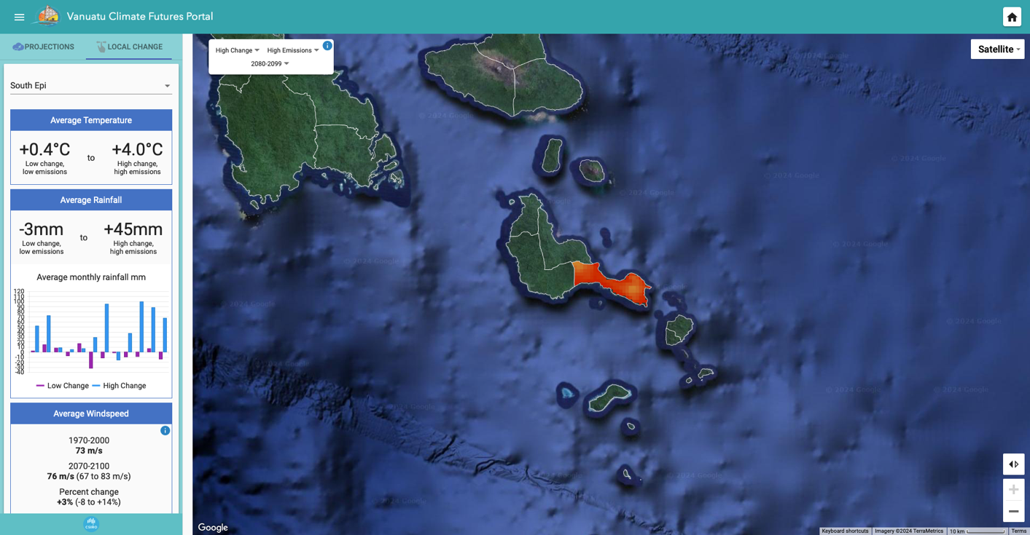
Figure 3: Local change for South Epi under high change, high emission. Source: Van-KIRAP Vanuatu Climate Futures Portal https://www.vanclimatefutures.gov.vu/

5. Problems and threats

This section outline priority coastal zone issues of Nalema Area and underlying causes as summarized in the table 4:

Table 4. Problems and threats and causes
Problems and threats | Underlying causes
Overharvesting of invertebrate resources  Mud-crab, land crab, shellfish, eel fish | - Small resources base due to limited habitat  - Commercialisation of resources  - Lack of effective management control  - Modern fishing techniques such as use of net  - Lack of other alternative livelihood and protein options  - No enforcement of fishing net size regulation  - Lack of knowledge about biology of species  - Regulations are not respected
Overharvesting of reef fish resources | - Small resource base limited by habitat size  - Uncontrolled use of gill netting.  - No fishing closure, size limit or quota limit on lake fishing.  - No enforcement of fisheries regulation  - No development offshore tuna fisheries
Lake Nalema ecosystem degradation | - Sea surface warming of the lake caused by global warming  - Cutting of mangrove and forest for cattle grazing and runway construction  - Flooding during heavy rain and siltation of the lake and eutrophication of the lake from poisoned vines and rotting leaves causing mass fish kill  - Flooding and opening of the Western barrier causing changes in lake water circulation.  - Lack of advice on mangrove removal
Invasive species outbreak | - Introduction of Tilapia and explosion of the tilapia population, lack of human utilization of Tilapia leading to impact on other species.
Brainwashed by church believe | - SDA Church belief of unclean food sources influence behaviour against taking care of these invertebrate marine species.
Ineffective MPA and Management of the lake fishery | - No awareness about fisheries management  - No enforcement of size limit for mud crab  - No size limit for bonefishes and mullet species  - No quota closed season control for these lake resources
Fishers Association not active | - Nalema fishers Association not working effectively in assisting lake fishery management control  - Nalema Fishers Association lack training  - Lack of skills in fish processing and value adding  - Lack skills in working together in a cooperative
Fishing technology lacking | - Lack of FAD fishing gears to attract fish  - Lack of resources to buy boat to make good catch  - Fishers do not work together  - Fishers competing with each other  - Lack of skills to develop small pelagic fishery
Fish Marketing services | - No training on fish value adding to extend shelf life  - Inadequate fish storage infrastructure in place  - No regular market access to Port Vila  - Fuel price is expensive
Lack of catch data collection | - Fish catch data not collected and no TAILS Monitor  - Boats are not registered and licensed  - Canoe are unregistered  - Spear guns not controlled  - No education and awareness of importance of data
Lack of skills in new fishing techniques and FAD management | - No training services provided by government  - Lack of FAD deployment at Nalema  - Lack of active fishermen’s association
Navigational aid and new knowledge of current change due to CC | - No navigation light on the island anchorage  - Lack of safety training during bad weather  - Lack of safety gears
Lack of alternative income activity | - Low copra price has affected production and loss of income option  - Reduced cattle quality due to poor pasture reduces production and sale  - Low investment in other cash crops such as coco, kava and vanilla  - Handicraft production is not seen as a source of income  - Tourism development is non-existent
Awareness and education | - Not enough awareness to fisheries management and conservation as a whole.  - No enough education for schools in marine resource management
Sustainable farming in upland areas. | - Not enough awareness about farming in upland areas.  - Farming of perennial crops in the flood plains to be timed away from flooding seasons.

6. Economic Activity in the coastal zone

6.1 Fishing activities

Fish has been a continuous source of income all year round and become a continuous harvest from this sea, currently the main source of economic activity for the people of Nalema. Fish is sold in the village to Mother’s Bazar market twice weekly and shipped to Tongoa Market at Morua and by interisland and by banana boat to Port Vila markets. The fish catch for shipment to Vila is aggregated in the solar deep freezers till the catch is enough to fill eskys for shipment to Vila. Shipment is made every week but fuel cost is a significant cost of operation. The current annual catch is not known at this stage but catch data is being collected and will be reported in the future. The most highly priced products are Tuna and tuna-like species and Poulet both at 500vt per kg village selling pieces and slightly high prices in Tongao Market and higher price in Port Vila Market at Manples or Marobe Market. The NFA runs a village fish market centre with solar deep freezers provided under government cyclone recovery project support and are working well to service the fishers of Nalema. The associations have indicated the need for two more deep freezers to increase the storage capacity for five fishing boats.

Table 3. Selling prices of fish from Nalema (from Fishers)
English common Name | Scientific Name | Market Prices /kg (VT)
 |  | Village market | Morua market, Tongoa | Port Vila market
Tuna like species | Thunnus albacares | 500 | 600 | 1500
Red poulet | Sargocentron spp | 500 | 600 | 1500
White poulet | Sargocentron spp | 500 | 600 | 1500
Bream like species | Abramis brama | 500 | 600 | 1500
Deep bottom grouper | Epinephelus spp | 300 | 300 | 800
Mix deep bottom fish |  | 200 |  | 1500
Wahoo | Acanthocybium solandri | 500 | 600 | 1200
Mahimahi | Coryphaena hippurus | 500 | 600 | 1200
Reef Fish | Reef fish spp | 200 | 300 | 800
Coral Trout | Epinephelus spp | 300 | 400 | 800
Black tuna | Acanthuridae sp | 300 | 400 | 800

6.2 Copra production and cattle grazing

Economic diversity is important in capture fisheries management to relief fishing pressure on resources. Copra and cattle are traditional cash crops for the community of Nalema for many years and these crops occupy much of the flood plain of Nalema. At the prime time of copra production and cattle sale in the 1980s to 1990s, fishing was more important for food security. This had changed with drop in the buying price of copra which effectively reduce production and loss of an income option. The current price is between VUV 79.98 and VUV 148.54 per kilogram or VUV 79,000 – VUV 148,000 per tonne or equivalent to 15 bags of 70kg weight which is too low and dis not worth the effort for farmers. Likewise the Nalema ranch, a large community owned cattle ranch with over 400 heads in the past had greatly reduced in stock population and quality. The ranch use to produce cattle supply to the Port Vila beef Industry but this market has been lost from reduced stock and poor quality animals. Pasture quality has greatly reduced by overgrown bushes from pasture management and this is contributed by low copra production and lack of cleaning of the plantation which encourage weed overgrowth. This is typical of locally owned cattle farms which are small-scale semi-commercial farms based on local breeds, less capital intensive, poor pasture, no veterinary checks and often overstocking.

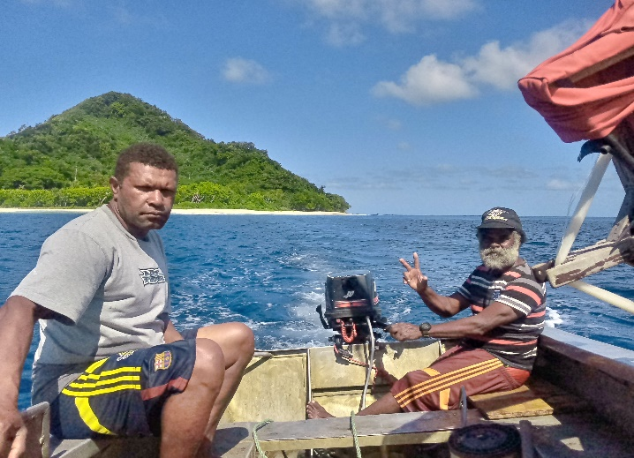 | 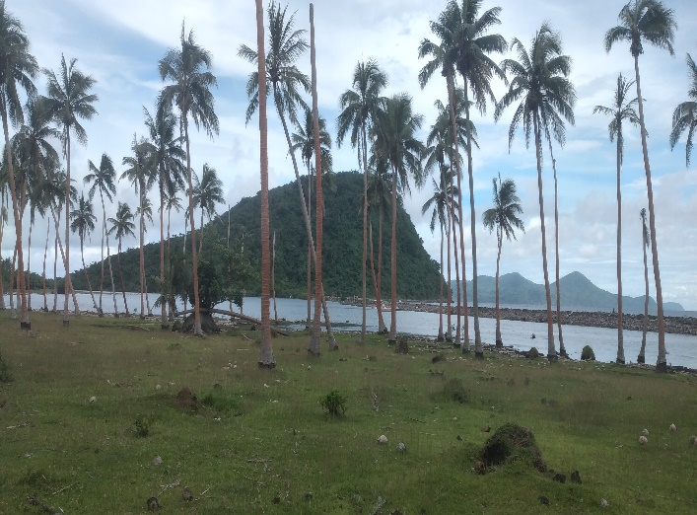
Fishermen of Nalema | Cattle & coconut, traditional cash crop of Nalema
Figure 4. Economic activities for Nalema community

6.4 Root crops and vegetables

Fish and seafood is always prepared and eaten with root crops and vegetable and it is inseparable. Nalema like other parts of Epi has very rich soil for farming of agriculture root crops such as taro, yam and kumala, banana, cabbages and watermelon. These crops are for food security and surplus are sold to Port Vila market and depending on quantity, agriculture crop to generate good income.

6.5 Tourism opportunity

Tourism development is a non-existent activity in Nalema despite the attractive environment of the area. Considering Nalema’s natural marine environmental attraction and its closeness to the Capital Port Vila, Nalema poses potential for tourism development with the lake environment, Kambioko island nature reserve, bonefish recreational fishing and troll fishing around the area present a good package of ecotourism activity worth exploring. There are no bungalows in the village however the good running water presents a high potential for development of a proper guest house. The marine and terrestrial environment is unique and special in its own ways which presents potential for the development of tourism. Developing small recreational fishing in the lagoon for bonefish present a potential good candidates for support of existing fisheries activities.

6.6 Cooperative and Trade

A cooperative store is active in the village to bring in the services needed by the Village and contributed to the economy of the Island. Several small-scale retail shops have established in the village who source consumer supplies from wholesales in Port Vila. Organisation of fish marketing business in Nalema is working but still in its infancy and if well-established could became a cooperative in future. It is important to strengthen existing cooperative to become the main entity to assist the economy of the area and island.

6.7 Handicraft making

The people of small islands have special skills in handicraft making as part of life. Women of Nalema produced handicraft are woven products such as mats, basket, fan and necklace from pandanus and coconut leaves. The main handicrafts for the women of Nalema are mats, and should tourism be developed, handicraft making of souvenirs need to become more organised and there are materials available to do this including pandanus, wood, nuts, stones and seashells, stone, and coconut husk are common local materials available. Often fish bones are used in some small handicrafts but is rare nowadays.

6.8 Transport services

The use of banana boat had surged after the COVID lockdown following disruption of flight and interisland shipping services to the northern Shefa province. Effective enforcement of licensing and safety standard for small boat for transport and fishing by the Office of the Maritime Regulator (OMR) had encouraged the growth of the boat transport between the shepherds island to Efate. The enforcement of sea safety regulations, licensing of small boat transport services and fishing boat operators, and associated training of operators have all contributed to the improvement of small boat services. The four licensed fishing boats in Nalema also provide passenger services in Epi, to Tongoa and shepherds islands and to Emua wharf on Efate at VT 8,000 for Nalema to Tongoa and around 40,000vt to Emua Jetty on Efate etc. This has helped improved travel and movement of produce to the markets, boosting economic activity. Additional income from transport services is helping to supplement income from fishing for fishing boat operators.

7. Community based Fisheries management proposal

This section provides proposals for the management and development of coastal marine environment and fisheries in Nalema to achieve sustainable marine resources use and habitat recovery and protection. Activities proposed are targeted at ensuring food security and livelihood needs are prioritized for the people of Nalema and are used as gateway to get community into resources management and conservation. The issues and constraints for Nalema coastal zone are:
a) Overharvesting of resources,
b) Lack of resource assessment and monitoring,
c) Marine protected area management,
d) Mangrove and seagrass habitat protection,
d) Loss of species from overfishing,
e) Coastal wildlife conservation,
f) Fisheries livelihood development,
g) Secure livelihood,
h) Improve fish marketing network,
i) Tourism development and handicraft making,
j) Collection of fisheries catch data collection and
k) Lack of skill training.
l) Improve copra price and production
m) Improve cattle production

7.1 overexploitation of reef and lagoon resources

Overexploitation is the main cause of resource depletion. Growing population and demand for food security and livelihood is putting pressure on resources. Already some resources have been over fished, the following table provides priority activities to ensuring resources are utilised in a sustainable manner. The main activities to address resource overexploitation are:
- Set up the Lake Nalema CCA.
- Introduce total ban on fishing in Lake Nalema CCA.
- Introduce regulation to ban on fishing for bonefish nationally and promote catch release.
- Introduce minimum size regulation for bonefish, mullet, mud-crab and land crab species.
- Introduce minimum size regulation for all commercial reef fish species.
- Introduce regulation to ban mud-crab harvest nationally until stock recovers.
- Introduce seasonal closure by area and species for threatened species.
- Introduce minimum size limit for Land crab harvest.
- Ban on night spearfishing.
- Enforce gillnetting mesh size limit.
- Ban on coconut crab harvest.

Table 5. Priority activities for resource overexploitation
Activity | What needs to be done | Responsibility
Seasonal closure of lagoon resources | - Setup Lake Nalema Conservation area (CCA)  - Ban on all fishing in the CCA to allow recovery | VFD  Van-KIRAP, other partners
Bonefish resource recovery | - Ban harvesting of bonefish in Nalema for some years to allow recovery of the resource  - Develop new regulatoru measure to ban harvesting of bonefish in Vanuatu to allow recovery  - Monitoring of bonefish stock in Nalema  - Develop catch and release fishery for bonefsh to promote recreational fishing and use this activity to monitor resource recovery | VFD  Van-KIRAP, other partners
Mullet resource recovery | - Ban harvesting of mullet in Nalema for some years to allow recovery  - Ban harvesting of mullet nationwide and introduce closed seasosn when stock recover | VFD
Land Crab resource recovery | - Ban land crab harvest at Nalema for some years to allow recovery.  - Conduct resource assessment and introduce harvest quota in future | VFD
Mud crab resource recovery | - Ban mud crab harvest at Nalema to allow recovery of stock  - Introduce regulation to Ban mudcrab nationwide for some years to allow recovery.  - Assessment of mud crab stock recovery | VFD  Van-KIRAP, other partners
Introduce new minimum harvest size limits for different species | - Introduce national minimum size limits species and open harvest season for bonefish and mullet species.  - Introduce national minimum size limit, open harvest season and catch quota for mud-crab and Land crab species and ban harvest of egged females  - Introduce minimum size limit for all commercial reef fishes  - Voluntary enforce these minimum size limit regulation by Nalema community assisted by Community authorized officer | VFD,  Community,  Van-KIRAP, other projects
Control of harmful fishing gears | - Introduce regulation to ban night spearfishing fishing nationally  - Enforce night fishing regulation in Nalema  - Enforce net size limit regulation | Vfd,  Van-KIRAP

7.2Monitoring of resources and ciguatera fish poisoning

Assessment of rock fishery resources is rarely conducted in Vanuatu and conducting such as study would be interesting to assess fish species diversity in this habitat system. Ciguatera fish poisoning is also very common for these rock associated species and it will be interesting to assess Algal bloom on rocky shores compared to coral reef systems. Monitoring increase prevalence of ciguatera fish poisoning is important to understand the fish species involved and changes and the type of ciguatera poisoning and therefore setting up monitoring research of seasonality and species infected by ciguatera poisoning is important to inform of the safety of fish consumption. The main activities to address resource and ciguatera poisoning are:
- Assessment of fish species associated with rock habitat and establish baseline data
- Assessment of invertebrate resources associated with rocky shore habitat.
- Baseline assessment of reef fish resources of rocky shores
- Baseline assessment of ciguatera fish poisoning
- Establish catch data collection to monitor catch trend for rocky shore fishery
- Monitor sea service temperature from ocean buoys

Table 6. Priority activities for rockyshore resource monitoring research
Activity | What needs to be done | Responsibility
Monitoring of seawater temperature | Set up sea temperature monitoring | VFD,  Van-KIRAP
Baseline assessment of reef fish resources and invertebrate resources | Conduct resource UVC survey of reef fish and invertebrate resources  Conduct catch survey to monitor sizes and species composition and temporal changes in catch of reef and pelagic | VFD,  Van-KIRAP,  other projects
Ciguatera fish poisoning surveys | Survey of fishers and medical report, to find out seasonality of occurrences, species infected and areas of fish being infected, symptoms of poisoning and treatment especially native remedies | VFD,  Van-KIRAP,  other projects

7.3 Lake Nalema and Kambioko Conservation Area development

The proposed Lake Nalema and Kamioko Island Community Conservation area is a ridge to reef manage area encompassing the marine lake ecosystem and marine system along the coast of Nalema Bay and around Kamboko Island. The marine habits of the area include lagoon, mangrove and seagrass bed in the lake is fragile and susceptible to loss by climate change on constant flooding from runoffs and deforestation of mangroves for fuel wood and cattle grazing. The coastal habitat includes black sandy beach and rocky shores in Nalema Bat around Kambioko Island. The ecosystem is under pressure from overfishing of resources, habitat degradation from deforestation and cattle grazing and flooding buy runoff and contamination of the lake from upland runoff and sea water intrusion causing salinity changes. These habitats deserve protection to maintain ecosystem health and resources that are dependent on these habitat systems. Activities highlighted in Table are ear marked for implementation by the project and any other future projects. The main activities for the development of the CCA to address resource overexploitation and habitat degradation are:
- Identify and mapping of the Lake Nalema and Kambioko CCA area and display this in billboards
- Work with communities to set up the CCA
- Perform customary ceremony to launch the CCA
- Fencing of the CCA from the end of small water on the East to the end of big water
- Sourcing of mangrove seedling and forestry seedling
- Replanting of mangroves and seagrass to revegetation the lake habitat
- Replanting of forest trees cut down for the airstrip construction
- Assessment and identification of biodiversity significant areas
- Develop information centre at Nalema primary school
- Introduce education activities for primary school

Table 7. Priority activities for Community Conservation Area (CCA)
Activity | What needs to be done | Responsibility
Identify CCA area and boundary and community approval | Meeting with community to identify boundary and final endorsement of the CCA boundary  Work with community and DEPC to establish CCA  Sign agreement for the CCA establishment | VFD, DEPC  Van-KIRAP,  other projects
Mapping and signage and Signage | Develop mapping of CCA boundary  Install billboard with map of MPA areas | VFD, DEPC  Van-KIRAP,  other projects
Baseline Assessment of CCA area | BIORAP assessment of resources inside CCA – marine and terrestrial  Report coverage of sea grass and mangrove forest and habitat mapping | VFD, DEPC  Van-KIRAP, other projects
Awareness with community | Launching of CCA with community  Awareness and éducation about CCA  Set up information center in the village. | VFD, DEPC  Van-KIRAP,  other projects

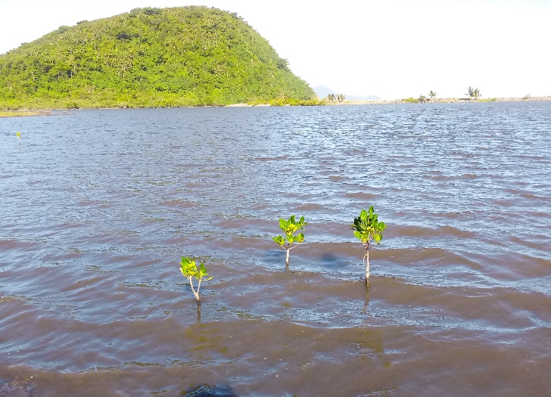 | 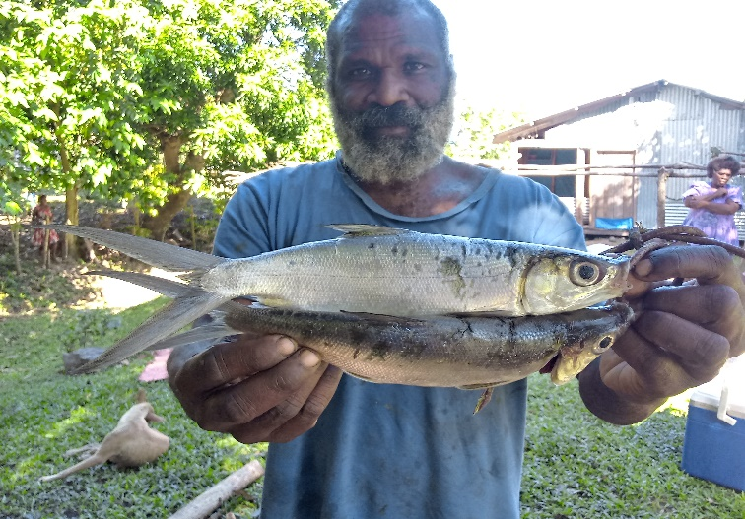
Replanting of mangrove | Bonefish resource overexploitation
Figure 5. Conservation activities an urgent need at Nalema area

7.4 Coastal wildlife conservation

Coastal wildlife comprises all marine resources including fish, invertebrates, reptiles such as turtles and marine mammals such as dolphins, dugongs and whales. Wildlife includes seabirds, crabs and coconut crabs and land crabs whose biology is dependent on the marine environment for shelter, food, and breeding cycle. Species such as dugongs, dolphins and whales are heavily protected under the Vanuatu Fisheries Act and must be respected by everyone in Vanuatu. The people of Nalema are no exception, they too must play their part in protecting these wildlife resources. The main activities to address resource overexploitation are:
- Voluntary enforcement of fisheries law
- Collection information of any of these wildlife species
- Voluntary enforcement of ban on harvest of turtle shells and turtle egg
- Preserve nesting site for seabirds
- Preserve special habitat for species
- Report on accidental deaths of marine mammal
- No disturbance of egg laying female turtle

Table 8. Priority activities for marine protected area
Activity | What needs to be done | Responsibility
Dugong management | Collect information about dugong and turtle present and abundance, seasons, feeding area | VFD, DEPC  Van-KIRAP, other projects
Turtle management | Ban on turtle killing, report on turtle sightings of turtles, nested turtles, tagging and reporting, education and awareness. | VFD, DEPC  Van-KIRAP, other projects  Chiefs and Area Council  Vanuatai monitor
Whale fish and dolphin management | Record of sighting of whales and dolphins  Report accidental landing of whales and dugon  No keeping in captivât of dugong and trutles | VFD, DEPC  Van-KIRAP, other projects
Seabird management | Document bird species, develop management guideline for seabirds | DEPC  Van-KIRAP, other projects
Protection of habitat | Work with Forestry and environment on preservation of habitat – seagrass, mangroves and coastal forest | VFD, DEPC  Van-KIRAP, other projects

7.5 Improve Fishing technology transfer and training

To diversify fishing effort to relief fisheries resources that are under pressure and develop new fisheries or fisheries that is in abundance, improvement of fishing technology is key. This means improving existing traditional practices or use new techniques to fish further away from shore or in deeper waters. Offshore pelagic resources and deep bottom fish resources and small pelagic fish are abundant resources available to supplement reef resources. The main activities to address resource overexploitation are:
- Development of new FAD design and deployment
- Introduce new fishing technology for large and small pelagic through training
- Introduce new fishing techniques for deep bottom fish
- Setup fishing gear shop in the island to support fishers
- Provide training on FAD development, maintenance and replacement
- Develop revenue activities to sustain FAD program at national level
Table 9. Priority activities for fishing technology transfer and training
Activity | What needs to be done | Responsibility
FAD development | Training on FAD construction and deploy,  Training on maintenance,  Complete FAD logsheet,  Conduct M& E on FAD after deploy | VFD,  Van-KIRAP, other projects
Fishing technology | Training of trainers,  Training of beginners | VFD  Van-KIRAP, other partners
Fishing gear availability | Set up gear shop at cooperative | VFD  Van-KIRAP, other partners
Training on new fishing methods for small pelagic fishes | Training for canoe fishers targeting small pelagic fishes | VFD  Van-KIRAP, other partners

7.6 Fish marketing improvement and value adding of fish products

Nalema community have established one village Fisheries Associations with 2 solar deep freezers to store fish. As a small community the association members are working together and better organising aggregation of their catches and shipment of fish to the market. The association currently face limited storage for their fish and request additional two freezers to increase their production. The main activities to address resource overexploitation are:
- Strengthening Nalema fishers association with fishing training and income generation and savings
- Installation of two more solar deep freezers
- Coordinated export of fish to Port Vila market and Tongoa Market
- Training on deep freezer maintenance
- Improve fish handline techniques
- Develop fish value adding techniques
- Cooperative business management
- Integrate with area council and provincial corporate plan

Table 10. Fish market improvement and product value adding
Activity | What needs to be done | Responsibility
Strengthening of Nalema fishers association | Organise training in fishing skills on OBM maintenance and fish handling | VFD  Van-KIRAP, other partners
Expand fish storage facility | Donate solar deep freezers to association  Training on basic deep freezer use and maintenance,  Monitor use of freezers, | VFD  Van-KIRAP, other partners
Training on fish handling and quality | Training of men and women and youth on fish handling, identification and quality control | VFD  Van-KIRAP, other partners
Training on fish value adding | Training on deboning, fillet and vacuum packed, raw fish preparation, trial on sun dried fish and  Smoked fish and cooking | VFD  Van-KIRAP, other partners
Training on business management | Run book keeping and financial management training for Association members and women’s group members. | Coop Dept.
Export of fish | Better organise fish export to Port Vila markets through Cooperative | VFD  Van-KIRAP, other partners

7.7 Fish catch data collection by electronic recording

Fisheries catch data collection is critical for assessment of production trend, stock health indicators and climate change impact on resources and fish catchability. For many years production information from Nalema is unknown and it is critical that this information is collected to assess resources stock and management decision. The main activities to address catch data collection are:
- Registration of motorized boats
- Listing of all canoes on the island
- Listing of spear guns on the island
- Training of electronic catch reporting and setup fishery data collection using TAILS
- Training on Fish ID, size measure and pricing
- Reporting of TAILS software data collection results into poster
- Fish market logsheet recording
- Document local fish ID in local dialect
Table 11. Priority activities for catch data collection and electronic recording
Activity | What needs to be done | Responsibility
Registration of fishing boats | Register all boats, keep record of canoe and spear gun | VFD
Purchase of Tablets for data collection | Purchase two tablets for use in Nalema for recording data on TAIL | VFD  Van-KIRAP,  other partners
Training on catch data collection using TAIL | Training on fish identification, size measurement and pricing, recording on logsheet,  use of TAIL | VFD  Van-KIRAP,  other partners
Reporting of data collection | Analysis of data and reporting with recommendations.  Produce poster and information about | VFD  Van-KIRAP,  other partners
Publicity of results and education | Publicise results in poster and presented back to community and decision making | VFD  Van-KIRAP,  other partners

7.8 Ecotourism development and handicraft making

The marine and terrestrial environment of Nalema is unique in its own ways and this uniqueness is an attraction which offer potential for ecotourism development. Strengthening of fisheries development on the island through FAD deployment and management of the lagoon and recovery of bonefish is a good candidate for development of small recreational fishing operators. Trolling for tuna and wahoo offshore around Kambioko Island offer great potential for small game fishing attraction. The main activities to address resource overexploitation are:
- Assessment of recreational fishing for bonefish and game fishing potential
- Initiate training of fishers on recreational fishing
- Development of fly fishing in the lagoon for bonefish
- Work with game fishing association to organise game fishing tournament
- Organise shell and wood handicraft and weaving training
- Linking tourism activity with Shefa Tourism Office

Table 12. Priority activities for rural tourism development
Activity | What needs to be done | Responsibility
Promote use canoe fishing | Assess potential for promoting local canoe use in the lagoon | VFD  Van-KIRAP,  other partners
Conduct training on game fishing | Train small boat operators about tourist and game fishing | VFD  Van-KIRAP, other partners
Organise trial on bonefish recreational fishing and offshore game | Work with game fishing association to assess potential for organising game fishing tournament  Provide price money for, small game fishing and canoe came fishing | VFD  Van-KIRAP, other partners
Handicraft training on weaving and wood curving | Train community members on shell and wood handicraft making | VFD  Van-KIRAP, other partners Tourism Dept
Promote development of local accommodation and bungalows | Community to encourage development of accommodation to support visitors | Community and Tourism Department can provide advice

7.9 Development of an Information centre

Information dissemination on marine resources, coastal ecosystems and management and conservation of resources is critical for education uptake of new ideas towards mentality change, responsible resource utilization and cooperation. Young generations are the ones to drive the change of tomorrow and an information centre for the island is a very useful facility to educate the community, schools and public. The centre is to hold all information material and a display area and notice board for information and can also be used for meetings. It will be an important facility for education and awareness about marine protected area, monitoring of resources, marketing and tourism activities. Information materials are expensive to produce but they are easily vandalized and destroyed by weather if not well kept out of rain and sun a closed building to keep information material can help the community keep important educational material safe from natural disasters. The main activities to address information dissemination are:
- Allocate funding for the information centre
- Meeting with the community and suggest the idea for building an information centre
- Identify a suitable site for the centre
- Purchase material and building of the building
- Designate management committee of the building
- Work with school on the information centre

Table 13. Priority activities for development and operation of Nalema information centre
Activity | What needs to be done | Responsibility
Meeting with community | Organise meeting with all committee and get their consensus on building a community centre | VFD  Van-KIRAP, other partners
Training/exposure of management officer on information | Exposure and training of local officers | VFD  Van-KIRAP, other partners

7.10 Ocean Observation and climate monitoring
Climate information such as current movement, temperature, salinity and clarity are important climatic information that can be used to improve fishing activities and better understand of seasons and tropical cyclones but these information are not collected and presented in a form that is understood by the community. The ocean buoys that is planned to be installed at Nalema will collected this information and channel it to the base in Vila and return to the community to use on their planning. The ocean information is to:
- Deployment of ocean buoys
- Training and awareness on the important of these buoys
- Management and maintenance of the buoys and instruments
- Presentation of the climate information gathered to the community

Table 14. Priority activities to address improved weather information from ocean observation and local knowledge of weather pattern
Activity | What needs to be done | Responsibility
Deployment of Ocean monitoring system | Meeting with committee about the instrument  Community to agree with deployment of the instrument | VFD  Van-KIRAP, Community
Security of the system | Community to assist monitor and take care of the ocean Buoy system | VFD  Van-KIRAP, community
Recording of local knowledge on weather and seasons | Interview elders and record local knowledge of cyclones, draught, rain, strong wind, rough seas, tsunami etc. and signs from plants and trees. | VFD  Van-KIRAP, community
Use of weather information to improve fishing activities | Information from ocean buoys to be presented in a simple information for community use | VMGD and VFD

7.11. Improve copra production

Copra is a traditional cash crop in Vanuatu and Nalema is the last productive area in the South of Vanuatu. While farmers are still keen on producing copra the low buying price has been discouragement. Support from the government is important to stabilise the price and ensuring sustainable production and maintenance of community livelihood. Copra and cattle go together and reviving copra cutting contribute to the cleaning of the plantation and pasture improvement for both copra and beef to relief pressure on the harvesting of marine resources.
- Government to look into raising the price and stabilise price to assist farmers
- Copra production is an incentive for cleaning of plantations, with the ongoing low prices, farmers are turning away from plantations which in the long run my lead to loss of production altogether.
- Responsible authority to look into supporting farmers with alternative markets such as virgin oil production.
- Shipment of coconut to food market in Port Vila is another option available for farmers.

Table 14. Priority activities to address Revival of copra production
Activity | What needs to be done | Responsibility
Falling copra price | Government to continue copra subsidy to maintain price at a sustainable level to provide support to local farmers | Ministry of Trade, Community
Coconut oil production | Responsible Government Agency to find alternative value adding process such as virgin oil production. | Ministry of Trade, Community
Sale of nuts | Dry coconut for food is in demand in Port Vila market, arrangement should be made for shipment of dry nuts to supply Port Vila Market. | Ministry of Trade, Community

7.12. Improve Cattle production

Nalema is an important cattle ranch for the supply of life cattle to Port Vila Market, however this marketing had stopped because of the low quality of the cattle. Cattle sale provide an important source of livelihood for the community and relieving pressure on the harvesting of marine resources. It is important the cattle industry is revived to productivity level with good quality stocks to revive the marketing of cattle to relief pressure on harvesting of marine resources.
- Organise community to agree on improving the cattle ranch and get everyone’s consensus.
- Improve the ranch by fencing into paddocks
- Cleaning of the buttocks and Improve pasture
- Improve cattle breed with some new breed
- Develop proper drinking well for cattle

Table 14. Priority activities to address improved cattle production
Activity | What needs to be done | Responsibility
Improve pasture | Introduction of new pasture seeds and planting | Livestock Dept and Community
Improve fencing | Divide the ranch into paddocks to better manage stock and pasture.  Fencing off the lake to revive the ecosystem
Improve cattle breed | Introduce new cattle breed | Livestock Dept. and Community
Cattle drinking water | Excess water supply is sufficient for cattle drinking but the water is being wasted and need to be properly welled for healthy cattle drinking. | Livestock Dept. and Community
Disease free cattle stock | Disease surveillance on cattle stock to maintain healthy animals  Culling of disease infected animals | Livestock Dept. and Community

Management Institution

8.1 Area Council

Nalema is in the Yarsu Area Council, the Area Councils is the lower level government of the area incharge of facilitating government services to the community and taking community needs up to the national government to address. The local government facilitates services in agriculture, education, health, housing, local government, planning, road transport, social services and fisheries. Area Administrator is the administrator is the administrator of the Area Council and is the main person responsible for government activities in the Area Council. The Area Council Secretary is a signatory of all memorandum with recipient communities and Fishers Association of Aniwa for implementation of respective activities in this plan. Specific roles of area council is to:
- Participate as a member of the Nalema Fishers Association
- Oversee implementation of the project activities on behalf of the Province
- Present priority annual work activities at Provincial meeting and incorporate into annual work plan of Area Council.
- Seek endorsement of priority fisheries activities at Area Council Meetings.
- Liaise with stakeholders, including governmental agencies, partners and donors
- Engage line agencies for implementation of the planned activities
- Coordinate, monitor and evaluate implementation of the management activities in the management plan
- Assist to coordinate enforcement of fisheries regulations and community rules

8.2 Community development committees

The different development committees in Nalema such as Nalema Fishers Association, Nalema Women’s Group, Water Committee, Health Committee, school committee and others and resource owners will implement the Nalema Community Based Fisheries management plan with the support of the respective government Agencies and non-government partners. The community will be responsible for the following undertakings:
- Take ownership of the plan and the projected activities.
- Implement annual planned activities
- Seek support from respective government agencies and NGOs and organize trainings, workshops at the community level
- Organize community awareness campaigns such as replanting of mangroves.
- Management of CCA and control of fishing activities in these areas.
- Collaborate with government line agencies to facilitate activity implementation.
- Monitor and evaluate activities implemented and report to Council.

8.2 Village Council

The village Chief and his Nasara Chiefs form the village Council whose role amongst others is to ensure

members of the community comply with the rules set out in this plan and the existing laws of the country

Governing marine and associated wildlife. The village council will enforce the following rules:

Resos | Community Rule | Community penalty and fine (proposed minimum fine for Community)
Bonefish | No fishing of bonefish in the lagoon | 1000 VT plus cus tom fine
Mullet | No fishing or killing of mullet in the Lagoon | 1000 VT plus custom fine
Other fishes | No fishing using spear, net or lining in lagoon. | 1000 VT plus custom fine
Mud crab / Kaldoni krab | No taking of any mud crab | 1000 VT plus custom fine
Lan crab | No taking of land crab | 1000 VT plus custom fine
Mangrove | No cutting or removal of mangrove | 1000 VT plus custom fine
Forest trees around the lake | No cutting of trees around the Lake | 1000 VT plus custom fine
Gill Netting | No gill netting in the lake | 1000 VT plus custom fine
Reef Fish | No fishing of undersize fishes | Release life fish, No sale of any dead undersize fish
FAD & Ocean Buoy and Research instruments | No damage of research instruments | 1000 VT plus custom fine
Dugong or Cowfish | Killing of cowfish is regulated by Fisheries Act | Penalty in Fisheries Act
Sea Turtle | Killing of turtle is regulated by Fisheries Act | Penalty in Fisheries Act
Rock Lobster | Size limit of gill net regulated by Fisheries Act | Penalty in Fisheries Act
Gill net | Size limit of gill net regulated by Fisheries Act | Penalty in Fisheries Act
FAD damage | Damage is regulated by Fisheries | Penalty in Fisheries Act
Night time diving with torch and spear gun | No night fishing from 6.00 pm to 6.00 am. | Penalty in Fisheries Act include confiscate gear

Process of council meeting on an infringement case:
Step 1 | Matter is reported first to the tribal chief, tribal chief resolve and penalise those involved using customary fines for first offender, second offender.
Step 2 | Chairman of council convene meeting and deliberate the report and infringement and fine the offender considering the last two fines given by Tribal chief
Step 3 | Third time offender is reported to the Village council following normal village protocol, Tribal chief take report to the Village Council.
Step 4 | Reoffending the fourth time, matter can be reported to Police for national police intervention.

8.3 SDA Church

The Seventh Day Adventist (SDA) is alive in Nalema and their work of the Church is very much alive. It is the common believe that certain marine and terrestrial species are considered “unclean” for consumption and this teaching can be a good conservation vehicle whereby because you do not use it, you can preserve it well and use it for livelihood. The church can make positive impact on resource and environmental conservation in the community:
- Conduct blessing prayer over the management plan and the activities of the plan
- Preaching on bible teaching about resource conservation and people roles
- Compose church song about Nalema and conservation area
- Organise youth to participate in village clean up and replanting of trees including mangroves.
- Organise exchange visits with other islands for youths.

Implementation Strategy

9.1 Implementation strategy

The implementation strategy for the Nalema community is already provide in Tables5 to Table 14. In this section, the Implementation Strategy for Priority Fisheries Activities is provided in Table 14 to assist Vanuatu Fisheries and Van-KIRAP prioritized their interventions to implementing the plan based on budget availability and the respective project scope.

Table 14. Proposed priority Fisheries sector activities for Nalema community.
ISSUES | MANAGEMENT ACTION | RESPONSIBILITY | OUTCOME
Overfishing of reef resources | - Enforce net size limit  - Enforce fish size limit on reef fish  - Ban on night diving  - Ban on catching fish during spawning aggregation  - Ban on catching rare fishes such as Napoleon wrasse and Humped Parrotfish  - Ban on fishing of bonefish and mullet  - Control use of net in the Lake  - Enforce size limit on reef fish | Community & VFD | Community fully comply with the laws
No monitoring of fish production in the area | - Training of Monitor  - Setup of community fish monitor (TAILS)  - Report on fish production by community | Community & VFD | Update statistics for sound decision making
Climate change, global warming and ocean acidification | - Assessment of damages by flooding Assessment of outbreak and organise COT clean-up  - Mass fish kill during flooding | Community & VFD | Up to date knowledge on impact of disasters
Ocean Observation system monitoring | - Deployment of the Ocean buoy monitoring system  - Monitoring of the monitoring buoy  - Report on the information collected to the community | Community & VFD, VMGD | Better planning of fishing and disaster preparedness
High fishing pressure on reef and Lagoon resources | - Development of FAD fishing  - Training on new fishing technology  - Development of new fisheries – flying fish  - Improve other income sources to relief pressure on the reef – cocoa, copra, livestock, kava | Community & VFD | Reduced fishing pressure
No Permanent MPA | - Set up permanent tabu area or MPA and register it under Environment Act  - Set up Permanent CCA – Community Conservation area to preserve wildlife include coconut crab and seabirds  - Conduct marine BIORAP assessment | Community & VFD, DEPC. Projects | Permanent MPA and conservation of resources
Ciguatera fish poisoning increasing intensity | - Need to monitor patient and fish eaten and symptom.  - Monitor source location of fish consumed and time of the year. | Community & VFD, DEPC. Projects | More awareness and reduced ciguatera poisoning
Conservation of marine wildlife | - Enforce ban on killing of turtles, dugong, dolphins and whales, seabirds  - Protect nest of seabirds and turtles | Community & VFD , DEPC | Protection of these species
Climate change and global warming | - Assessment of coral bleaching and report to VFD  - Crown of thorn starfish outbreak Assessment of outbreak and organise COT clean-up  - Mass fish kill during low tide | Community & VFD | Better informed decision
Fisher Association is weak and unorganised | - Set-up of Nalema fishers Association  - Establish fish marketing development with Cooperative  - MOA signed by community with VFD for all assets donated include freezers, FAD, fishing gears, fish processing tools | Community & VFD | Better organised fishing activities
No fish preservation and storage facility | - Set-up Nalema fish market building  - Managed by TIFA  - Stocked with Solar deep freezers | TI F/Association & VFD | Reduced wastage and improve value
Compliance to Fisheries laws is lacking | - Appointment of Fisheries Authorized officers  - Training of officers  - Registration of boats, nets, canoes and spear gun to comply with fisheries laws | Association | Sustainable resources
Improve water supply services | - Water supply is flowing well but pressure too high, need to relieve pressure to prevent damages,  - Reorganise Water committee to only one group  - Focus on development of water supply system for whole village. | Community and Department of Water Resources | Sustainable piping system and healthy water access
Other livelihood developments | - Training of women, men and youths in handicraft making from shells, rocks, wood, pandanas and coconut leaves and shells  - Training in small game fishing activities using small boats and canoe targeting wahoo and tuna  - Ecotourism development and bonefish trial | Women’s Group, VFD, Tourism, Community | Trained skilled numbers of community to develop livelihood activities.
Not enough Awareness and education | - Awareness meeting organised for community  - Setting up of a community information centre | Community and VFD, DEPC and partners | Better informed community

9.2. Steps in implementation of the plan

To achieve its objectives, other factors will be addressed to ensure the plan is successfully implemented. When implementing the plan, consideration should be given to the following:

Step 1; Implementing Strategy: The implementation strategy of this plan outline the broad objectives, indicators and implementing partners.

Step 2: Engagement with other projects: considering there are several projects working on community based management in Vanuatu, and to achieve tangible results, integration of project implementation is important to facilitate sharing of information and resources, foster unity and understanding in implementation of activities to the community.

Step 3: Nalema Fisheries Association: Strengthening of Nalema Fishers Association is important to better organise the community and channel community views to relevant line agencies for assistance.

Step 4: Engagement with line Agencies: To support implementation of activities identified in this plan, the community though Fishers Association will coordinate with other line agencies to attend. Line agencies in this case are Environment Dept., Climate Change Office.

Step 5: Socio-economic surveys and consultations: Joint SE surveys by projects is necessary to capture good baseline information towards development of management plan and to clearly identify activities.

Step 6: Capacity building: To effectively implement this plan, community workers including members of the fishers associations, cooperatives, women and youth groups and customary land owners, project partners must be trained and be made aware of various priority activity for Nalema.

10. Duration and Review

The CBFM Plan will be active for a period of 10 years maximum beginning in 2024 to 2034. This management plan will be reviewed after five years to assess implementation status and proposed new activities and changes. However, if a need does arise to amend the plan before this time, then an early amendment can take place with the approval of the respective area council and communities. This plan is also a living document and any change in activity will be proposed to the Van-KIRAP Steering Committee for approval. The review process must provide an opportunity for village representatives and other relevant stakeholders to comment on the content and implementation of the management plan. The proposed amendments must be endorsed by the respective area council and communities. Copies of the amended management plan must be distributed to five communities and all members of the stakeholder consultative group. Chiefs and communities can make changes to the plan whether to extend the plan or develop another plan for better management of their resources after year 2034. The plan will be reviewed after 2 years. Communities line government departments and community and other stakeholder groups will be part of the review.

Annex 1. Vanuatu Fisheries Regulation for Marine Resources

Species | Size limit | Other restrictions | Fine
Trochus | Min size – 9cm-Max size 13cm | Open fishery, License required for trade | 200,000 VT Individual 1,000,000 VT for company
Green snail | Min size 15cm | No commercial trade permitted | 200,000 VT Individual 1,000,000 VT for company
Triton shell | Min size 20cm | Ban of fishing | 200,000 VT Individual 1,000,000 VT for company
White troika | Min size 9xm |  | 200,000 VT Individual 1,000,000 VT for company
Sea cucumber | Size limit for commercial species in Annex 2 | Licensed traders only, based on TAC | 200,000 VT Individual 1,000,000 VT for company
Rock Lobster | Min size – 22cm | Restriction on female with egg. Hand collected | 200,000 VT Individual 1,000,000 VT for company
Slipper lobster | Min size – 15cm | Restriction on female with egg | 200,000 VT Individual 1,000,000 VT for company
Coconut crab | Min size – 9cm  Torres: 30 Oct – Nov 2, Quota -5000 crab  Santo: 31 May –  Maewo: 1st Nov – 30 April  Erromango – 1sept – 31 March |  | 200,000 VT Individual 1,000,000 VT for company
Turtle | Ban on killing of turtle, Traditional use exempted by permit only  No taking of egg or disturbance of nest  No killing or injury of Turtles with any weapon including spear  No keeping of turtles in captivity |  | 200,000 VT Individual 1,000,000 VT for company
Dugong or Cowfish |  | Ban on the killing of Cowfish | 50,000,000 VT
Aquarium fish |  | Flame Angel quota on Efate, open in other location | 200,000 v VT Individual 1,000,000 VT for company
Giant clam |  | License to trade, Ban on trade of wild giant clam | 200,000 v VT Individual 1,000,000 VT for company
Fishing using UBA |  | No catching of reef fish and invertebrate with use of Underwater Berating Apparatus | 200,000 VT Individual 1,000,000 VT for company
Coral and live rock |  | No commercial trade without License | 200,000 VT Individual 1,000,000 VT for company

Annex 2. Reef Fish Size Limit rule for Nalema (Proposed new rule)

Reef fish Species | Minimum Size Limit | Other Restriction | Fine for non-compliance and other actions
Napoleon Wrasse | 65 cm | Ban on the species | Release live specimen  Not for sale
Hump head parrotfish | 63 cm | Ban on the species | Release live specimen  Dead specimen Not for sale
Trevally fishes | 30 cm |  | Release live Undersize,  Dead undersize not to be sold
Unicorn fishes | 20 cm |  | Release live Undersize,  Dead undersize not to be sold
Surgeon fishes | 20 cm |  | Release live Undersize,  Dead undersize not to be sold
Scad mackerel | 15 cm |  | Release live Undersize,  Dead undersize not to be sold
Milkfish | 30 cm |  | Release live Undersize,  Dead undersize not to be sold
Drummer fishes | 20 cm |  | Release live Undersize,  Dead undersize not to be sold
Other wrasses | 20 cm |  | Release live Undersize,  Dead undersize not to be sold
Red snapper fishes | 30cm |  | Release live Undersize,  Dead undersize not to be sold
Red Emperor fishes | 30 cm |  | Release live Undersize,  Dead undersize not to be sold
Mullet fishes | 25 cm |  | Release live Undersize,  Dead undersize not to be sold
Goat fishes | 15 cm |  | Release live Undersize,  Dead undersize not to be sold
Parrot fishes | 20 cm |  | Release live Undersize,  Dead undersize not to be sold
Salala Mackerel | 20 cm |  | Release live Undersize,  Dead undersize not to be sold
Grouper | 25 cm |  | Release live Undersize,  Dead undersize not to be sold
Rabbit fishes | 20 cm |  | Release live Undersize,  Dead undersize not to be sold
Barracuda | 30 cm |  | Release live Undersize,  Dead undersize not to be sold

Annex 3. Restricted Fishing gear and closed area

Fishing gear | Restriction | Fine for non-compliance
Fish fencing | Allowed with Director Fisheries approval | VT 500,000 for Individual  VT 1,000,000 for company
Cast net | 20mm mesh size and 2m wide | VT200,000 Individual, VT1,000,000 for company
UBA | Not to be used to conduct any fishing activity | VT200,000 Individual, VT1,000,000 for company
FAD | No removal or damage of FAD | VT200,000 Individual, VT1,000,000 for company
Fishing net | Not less than 5cm mesh size | VT200,000 Individual, VT1,000,000 for company
Fish poisoning | Use of fish poisoning is illegal | VT200,000 Individual, VT1,000,000 for company
Spear for turtle | No killing of turtle with weapons | VT200,000 Individual, VT1,000,000 for company
Closed Marine area, Tabu area or MPA | A tabu area can be regulated under Fisheries Act and Fisheries enforcement and Police enforces the law over the area

